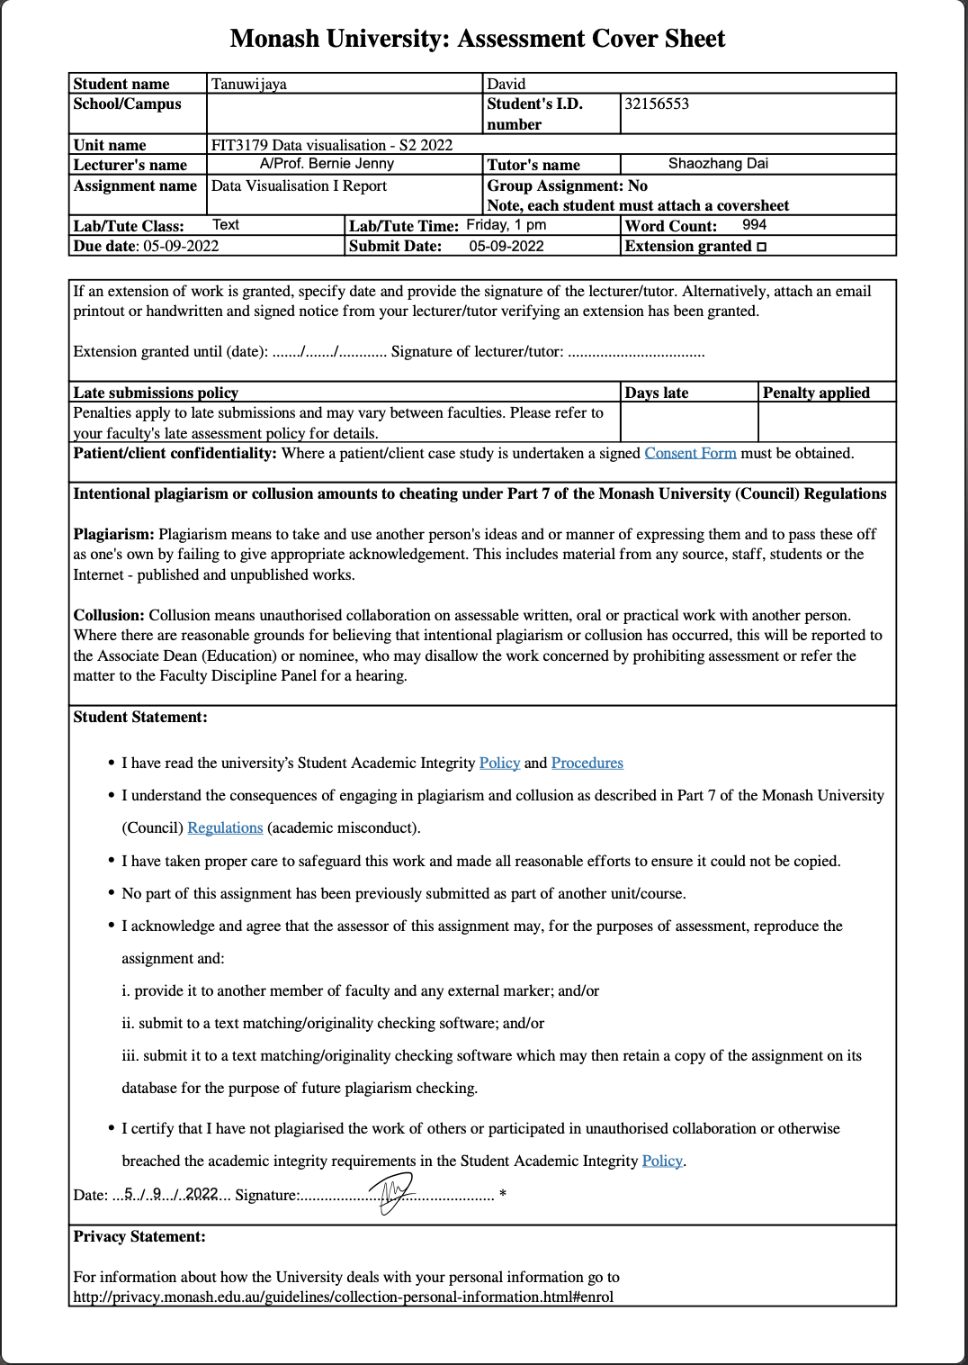

**Assignment 2: FIT3179 Data Visualization**

**Singapore’s Public Transport System**

[**https://dtwjy.github.io/Assignment2_Latest/**](https://dtwjy.github.io/Assignment2_Latest/)

­­

Name : **David Tanuwijaya**

Monash ID : **32156553**

Tutorial : Wednesday, 1 PM

Word Count : (excluding figure caption, appendixes, and references)

**Why and Who**

The visualisation aims to present and depict interesting facts about Singapore’s public transport system which are recognised as one of the best systems in the world. Overall, the fact was displayed in various types of graphs and statistical figures to view the data from different perspectives. The visualisation is mainly divided into 3 different sections of the broad overview/introduction, road vehicles, and railways system. The aim is to inform reader to know more about Singapore’s public transport system.

**What**

The data was derived from the Singapore’s Government of Public Transport department and other supportive public dataset from Kaggle. Most graphs are having a table type dataset, with combination of quantitative attributes (coordinates of the bus stops and train stations) with categorical variables assessed for each stations’ name and mode of transportation. Some of the information are presented in an ordinal way such as year and count data.

**Why and How**

1. International Student Growth Rate

As to the introduction of the topic on international students, we could assess the performance based on the qualitative attribute of the count of international student as the y axis and year in x axis. Furthermore, each bar chart represents the qualitative percentage difference of number of international students from year to year (%). This could be seen using line chart on showing the number of total international students onshore and a bar chart to specifically visualise the growth rate of differences in the number of international students from year to year whether its positive of negative. Colour are used to highlight the diverging growth rate for each year-to-year changes.

User could select the desired state or combine those states to see a more comprehensive and specific number of international student growth using the filter function.

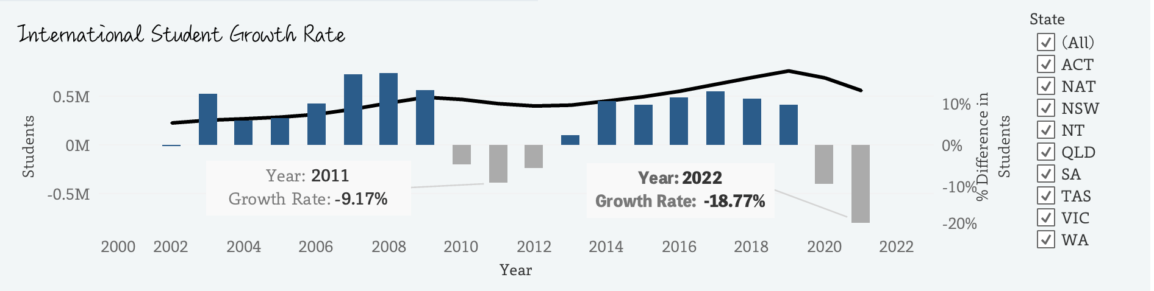

Figure 1: International Student Growth Rate with state selector

1. Demanded Education Sector

Australian government segmented international students into 5 different course level categories. Donut chart is used representing the proportion of the categorical variable in which the students are identified for. While the size of the chart was the number of international students counted for each category. Colour are used to differentiate different group in the chart.

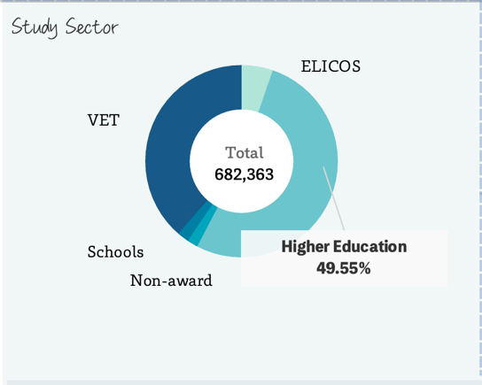

Figure 2: Donut chart of the education sector in Australia for international student enrolment proportion

1. Another background overview information which is highlighted in the visualisation is about student nationality based on each study topic which illustrates the specific interest of which nationality that Australia is appealing to and what subject is there that attracts most of the students.

Two different bar charts are used with highlighted highest value with colour. The bar chart was the idiom chosen to ease the comparison of the number across the different categories, both in terms of nationality background and broad field of education program based on student enrolment count.

Two different data attributes which are categorical (nationality and study topic) and qualitative (number of international students) which are clearly presented on the axis. Colour is used to indicate the highest value in the chart, while position is the main measure of importance in the case of bar chart, length is used to measure the different between different category count.

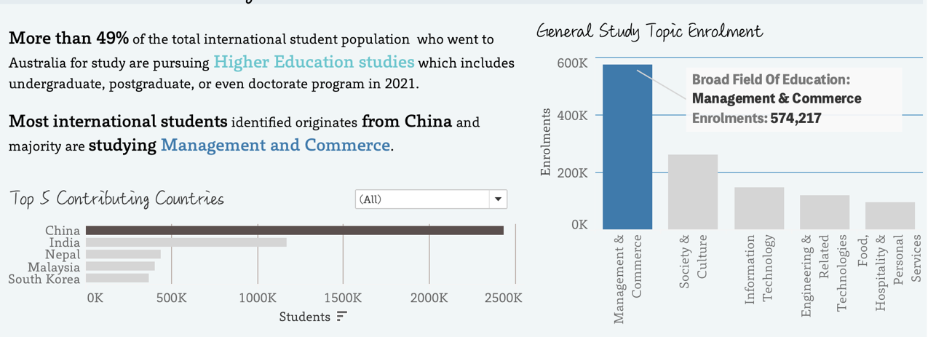

Figure 3: Bar chart used of showing the top contributing countries with selector by year and broad field of study topic.

1. The visualisation compares the number of international students in higher education with other countries and how Australia performs compared to other countries.

In this case, the combination of bubble chart and bar chart is used to represent the size of Australian international students in higher education compared to other countries. The bubble chart perfectly captures the size relative to other smaller countries (which Australia is quite substantial) and those major players (UK and USA). Additionally, bar chart displays the precise difference for those top 5 countries in numbers. Colour and size are used to differentiate the data by its category and student counts.

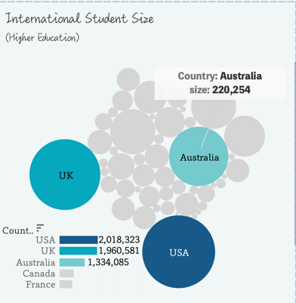

Figure 4: Combination of Bubble chart for size comparison and bar chart to show the specific number

1. Finally, the visualisation would like to highlight Australian higher education system where it took almost 50% count of total international student in Australia. Institutions are rank and compared based on their points determined by QS ranking, while also displaying the number of international student there is in the top universities onshore.

Bar chart is used in this case to represent the number of international students in the top 8 universities in Australia with colours hue luminance to represent each university. Length and position of the graph are used to measure the information itself.

Combination of bump chart and line chart is used to capture the rank changes from year to year for every university in Australia, with a selection of campuses to choose from on the filter tab. Colour hue and luminance is used accordingly, labelling each university by its ranking over the year.

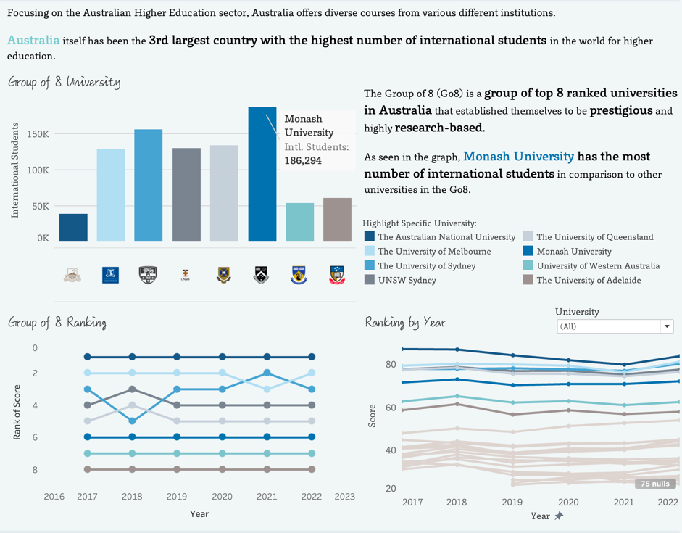­­

Figure 5: Bar chart showing the number of international students counted for the top 8 universities with rank labelled on each bar.

Highlighted figures are being spotted here and there on the dashboard to highlight specific information. Tooltip and chart highlight caption improve the flow and readability of the infographic.

**Dashboard Design**

The overall layout of the visualisation is mainly divided into 3 big rows and 3 columns with sub segmented part of introduction, road vehicles, and railways section. All the section was explained with at least one visualisation and graph description. Text arranged symmetrically and consistent layout throughout.

The visualisation majorly uses the combination colour of blue and grey, ranging from different luminance, highlighting different aspects of the information. Overall, the colour is consistent throughout the visualisation with clear usage of highlighted blue panel background to indicate the title and subheading. Colours are also used in some of the text descriptions to indicate the relationship between the data and its description.

Consistent sheriff typeface Toppan Bunkyu Gothic is used for body and lingWai SC for title and subtitles to represent the unique modern handwritten cursive font-type as using actual pen which matches with the student theme. Text weight, size, and colour differentiation are used to emphasize important information related to the relevant graph.

Graphical elements such as emojis are used in the title of the visualisation and sized accordingly to create visual cue and aesthetic reasons.

The storytelling aspect is one of the main objectives of the infographic, guiding the user readability and understandability of the infographic from start to end. The overall infographic is strategically placed to be read from left to right, with guided text assisting the user to understand the context the information and informative tooltip when hover across different visualisation.

**Appendix**

Five Design Sheet

Sheet 1

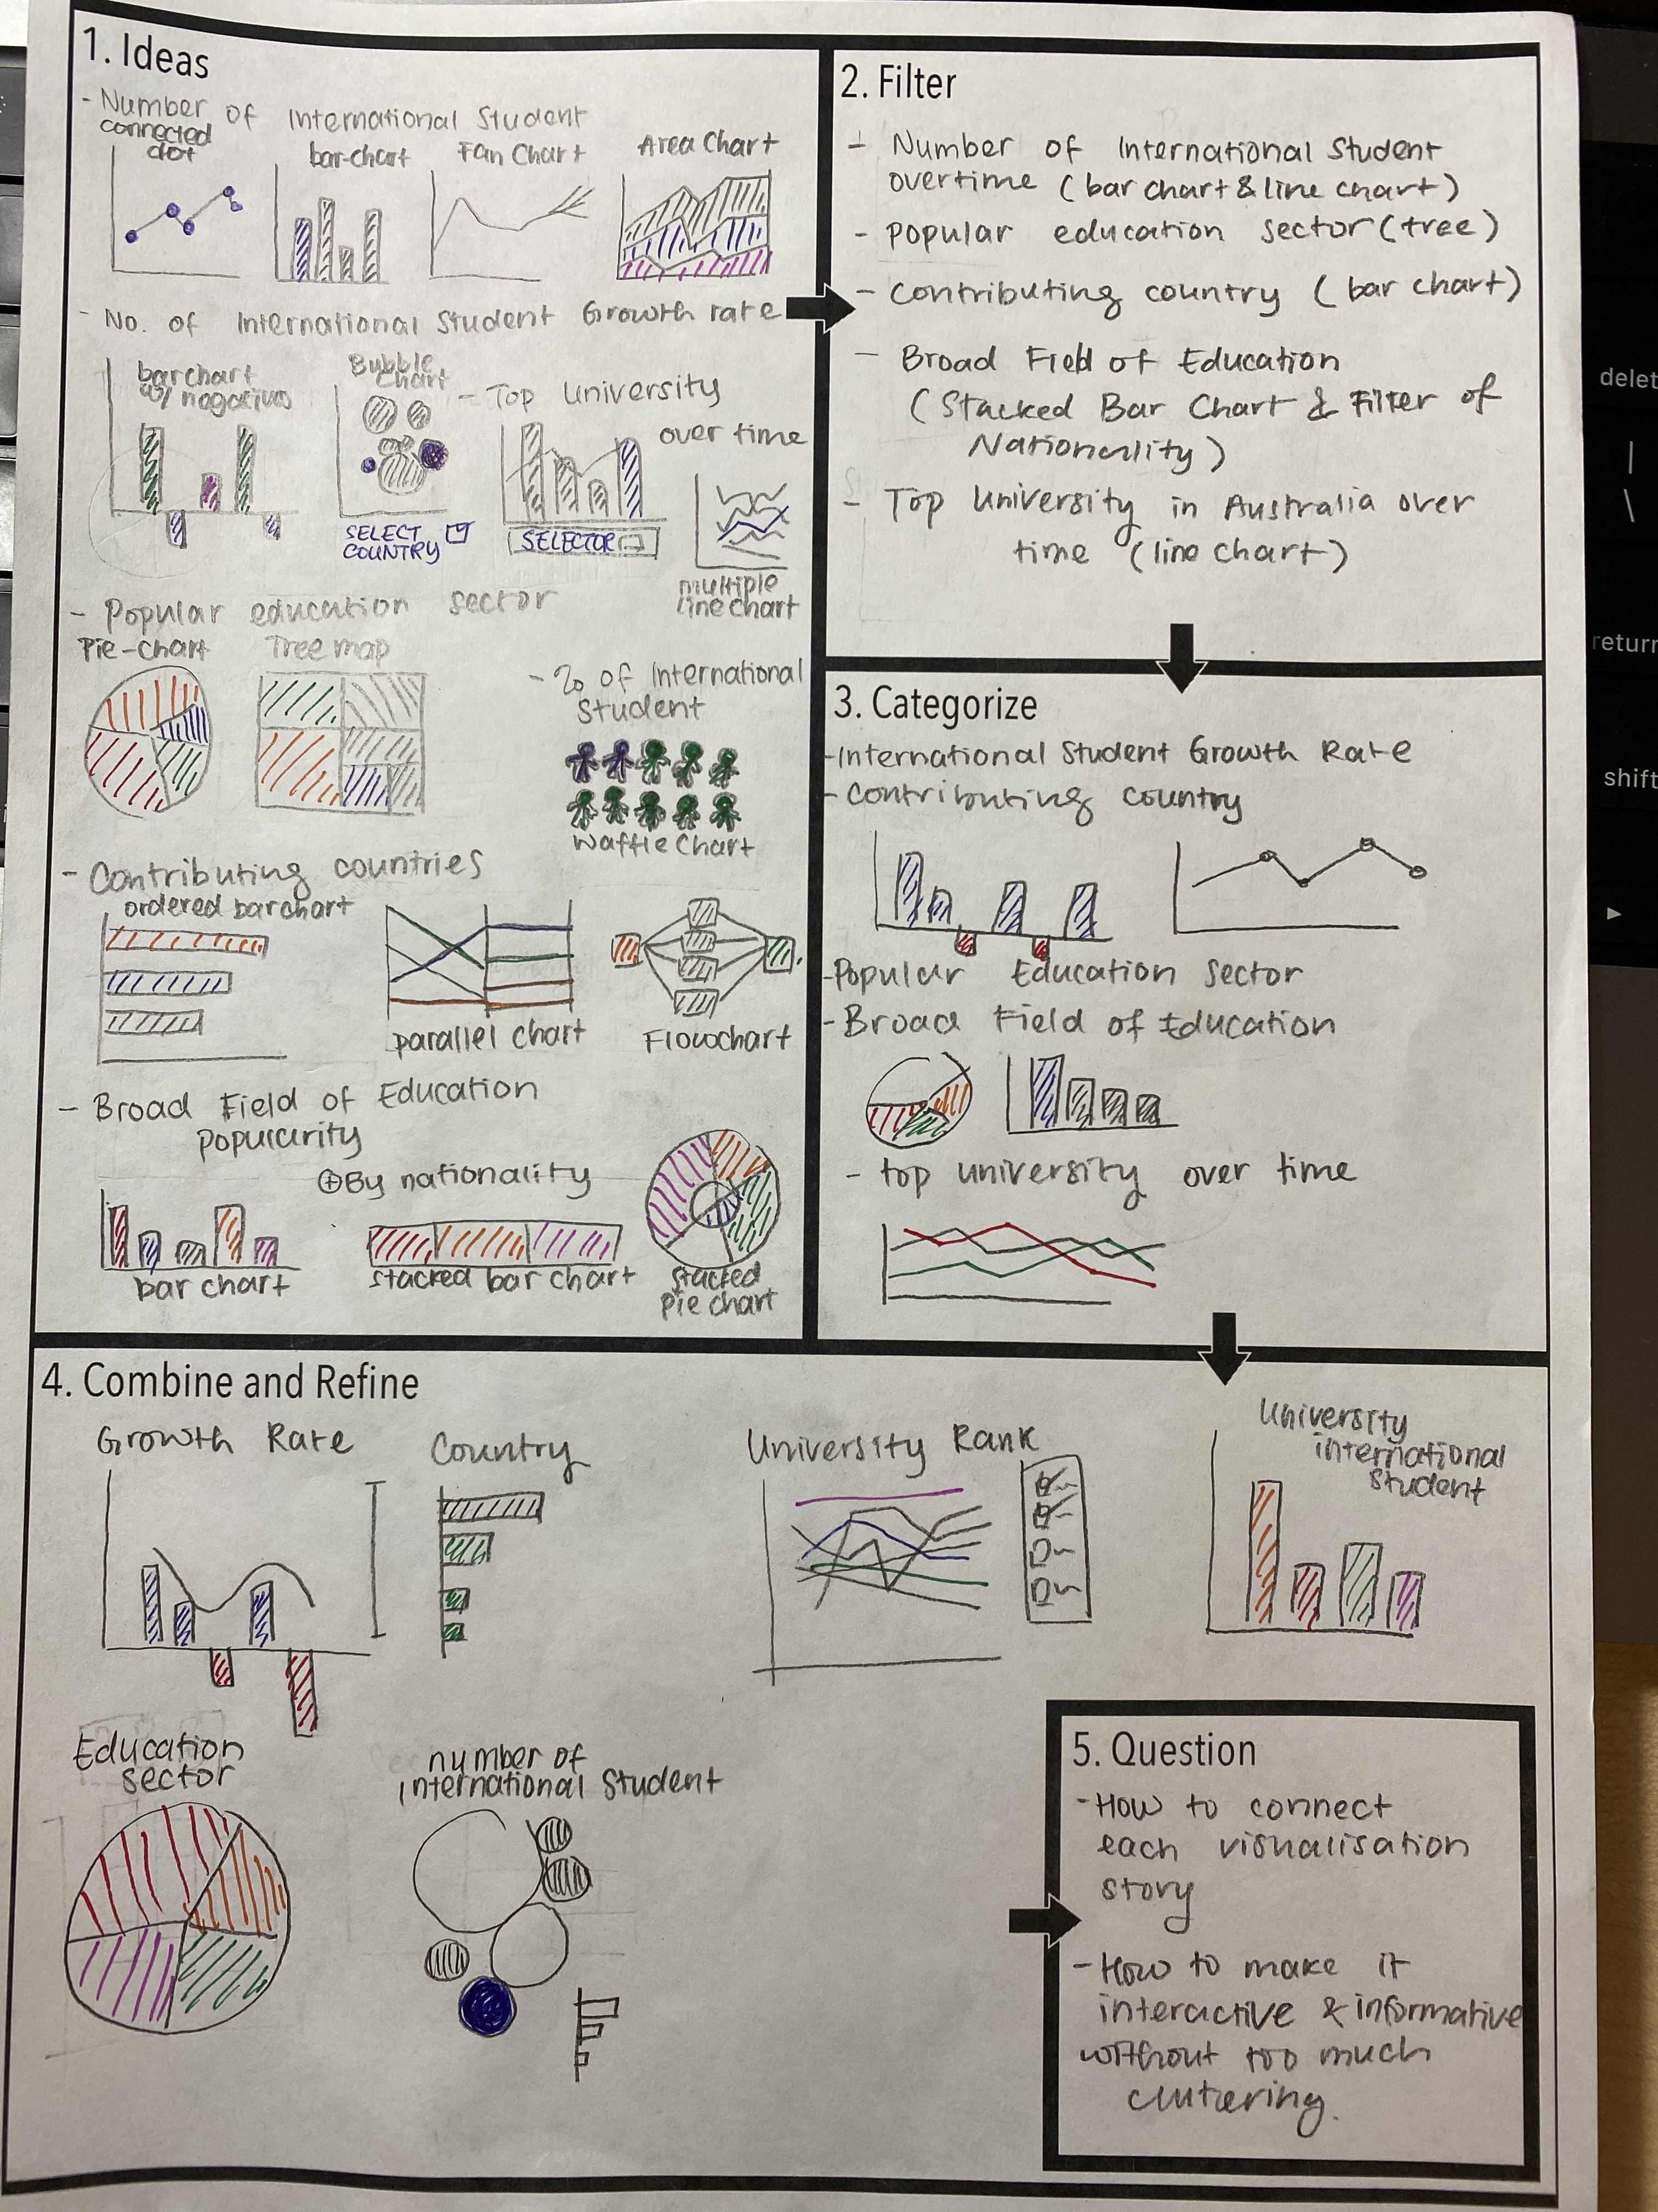

Sheet 2

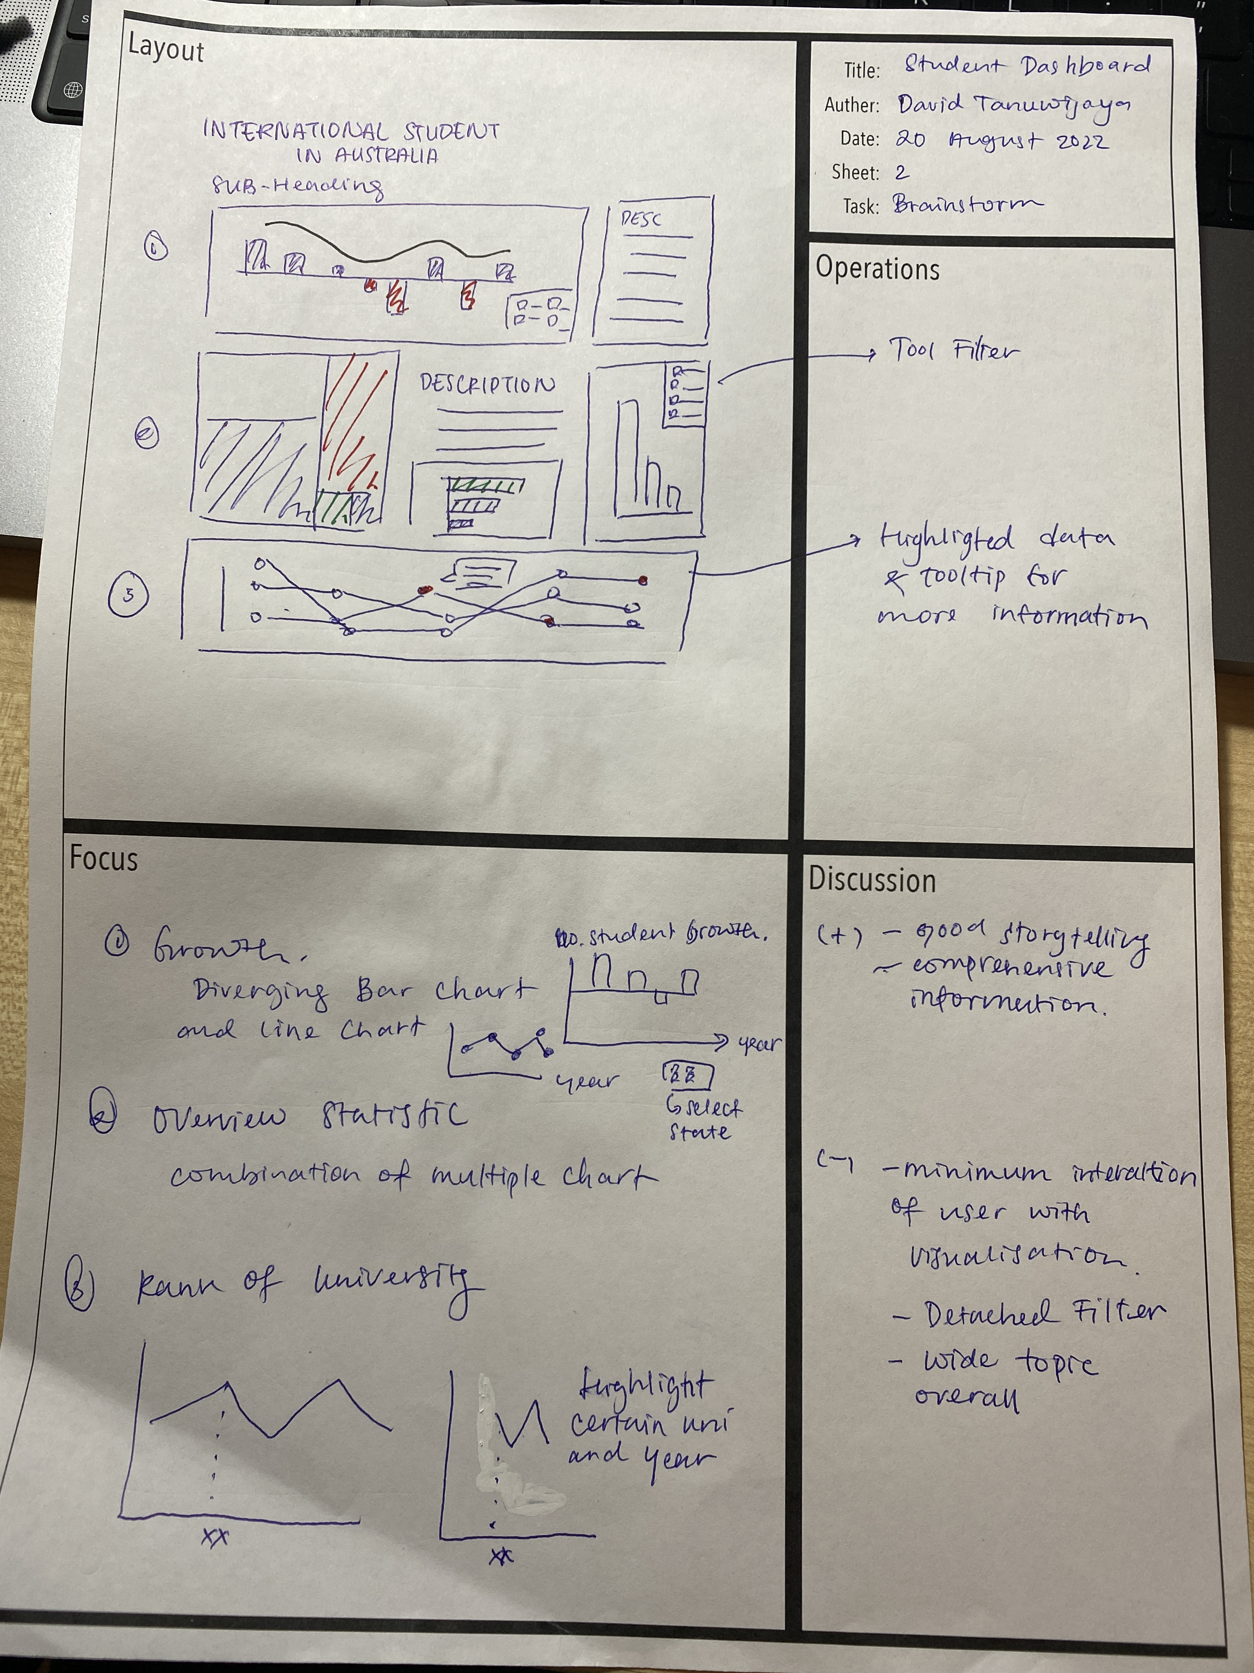

Sheet 3

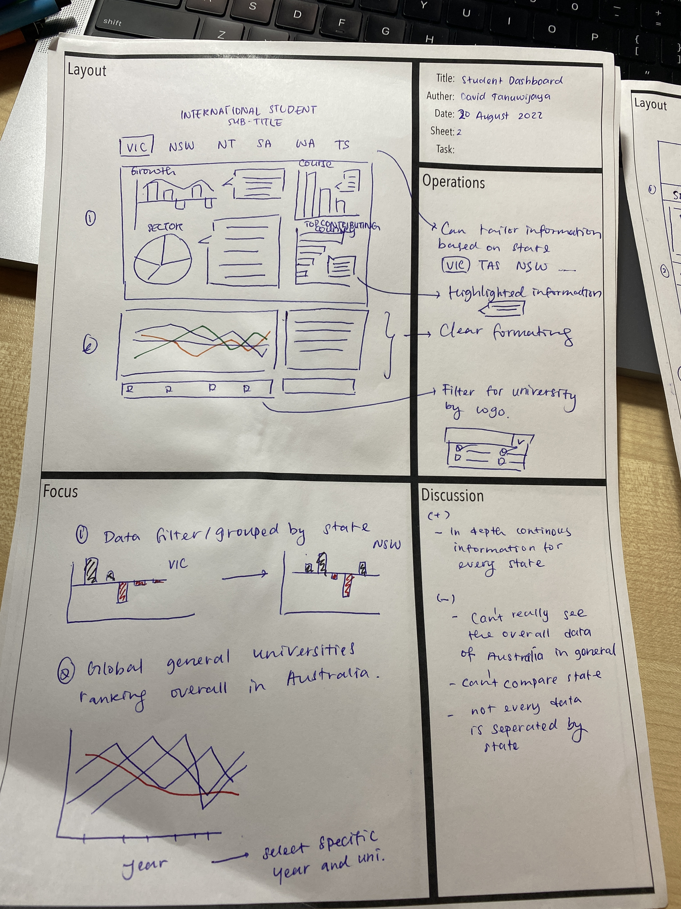

Sheet 4

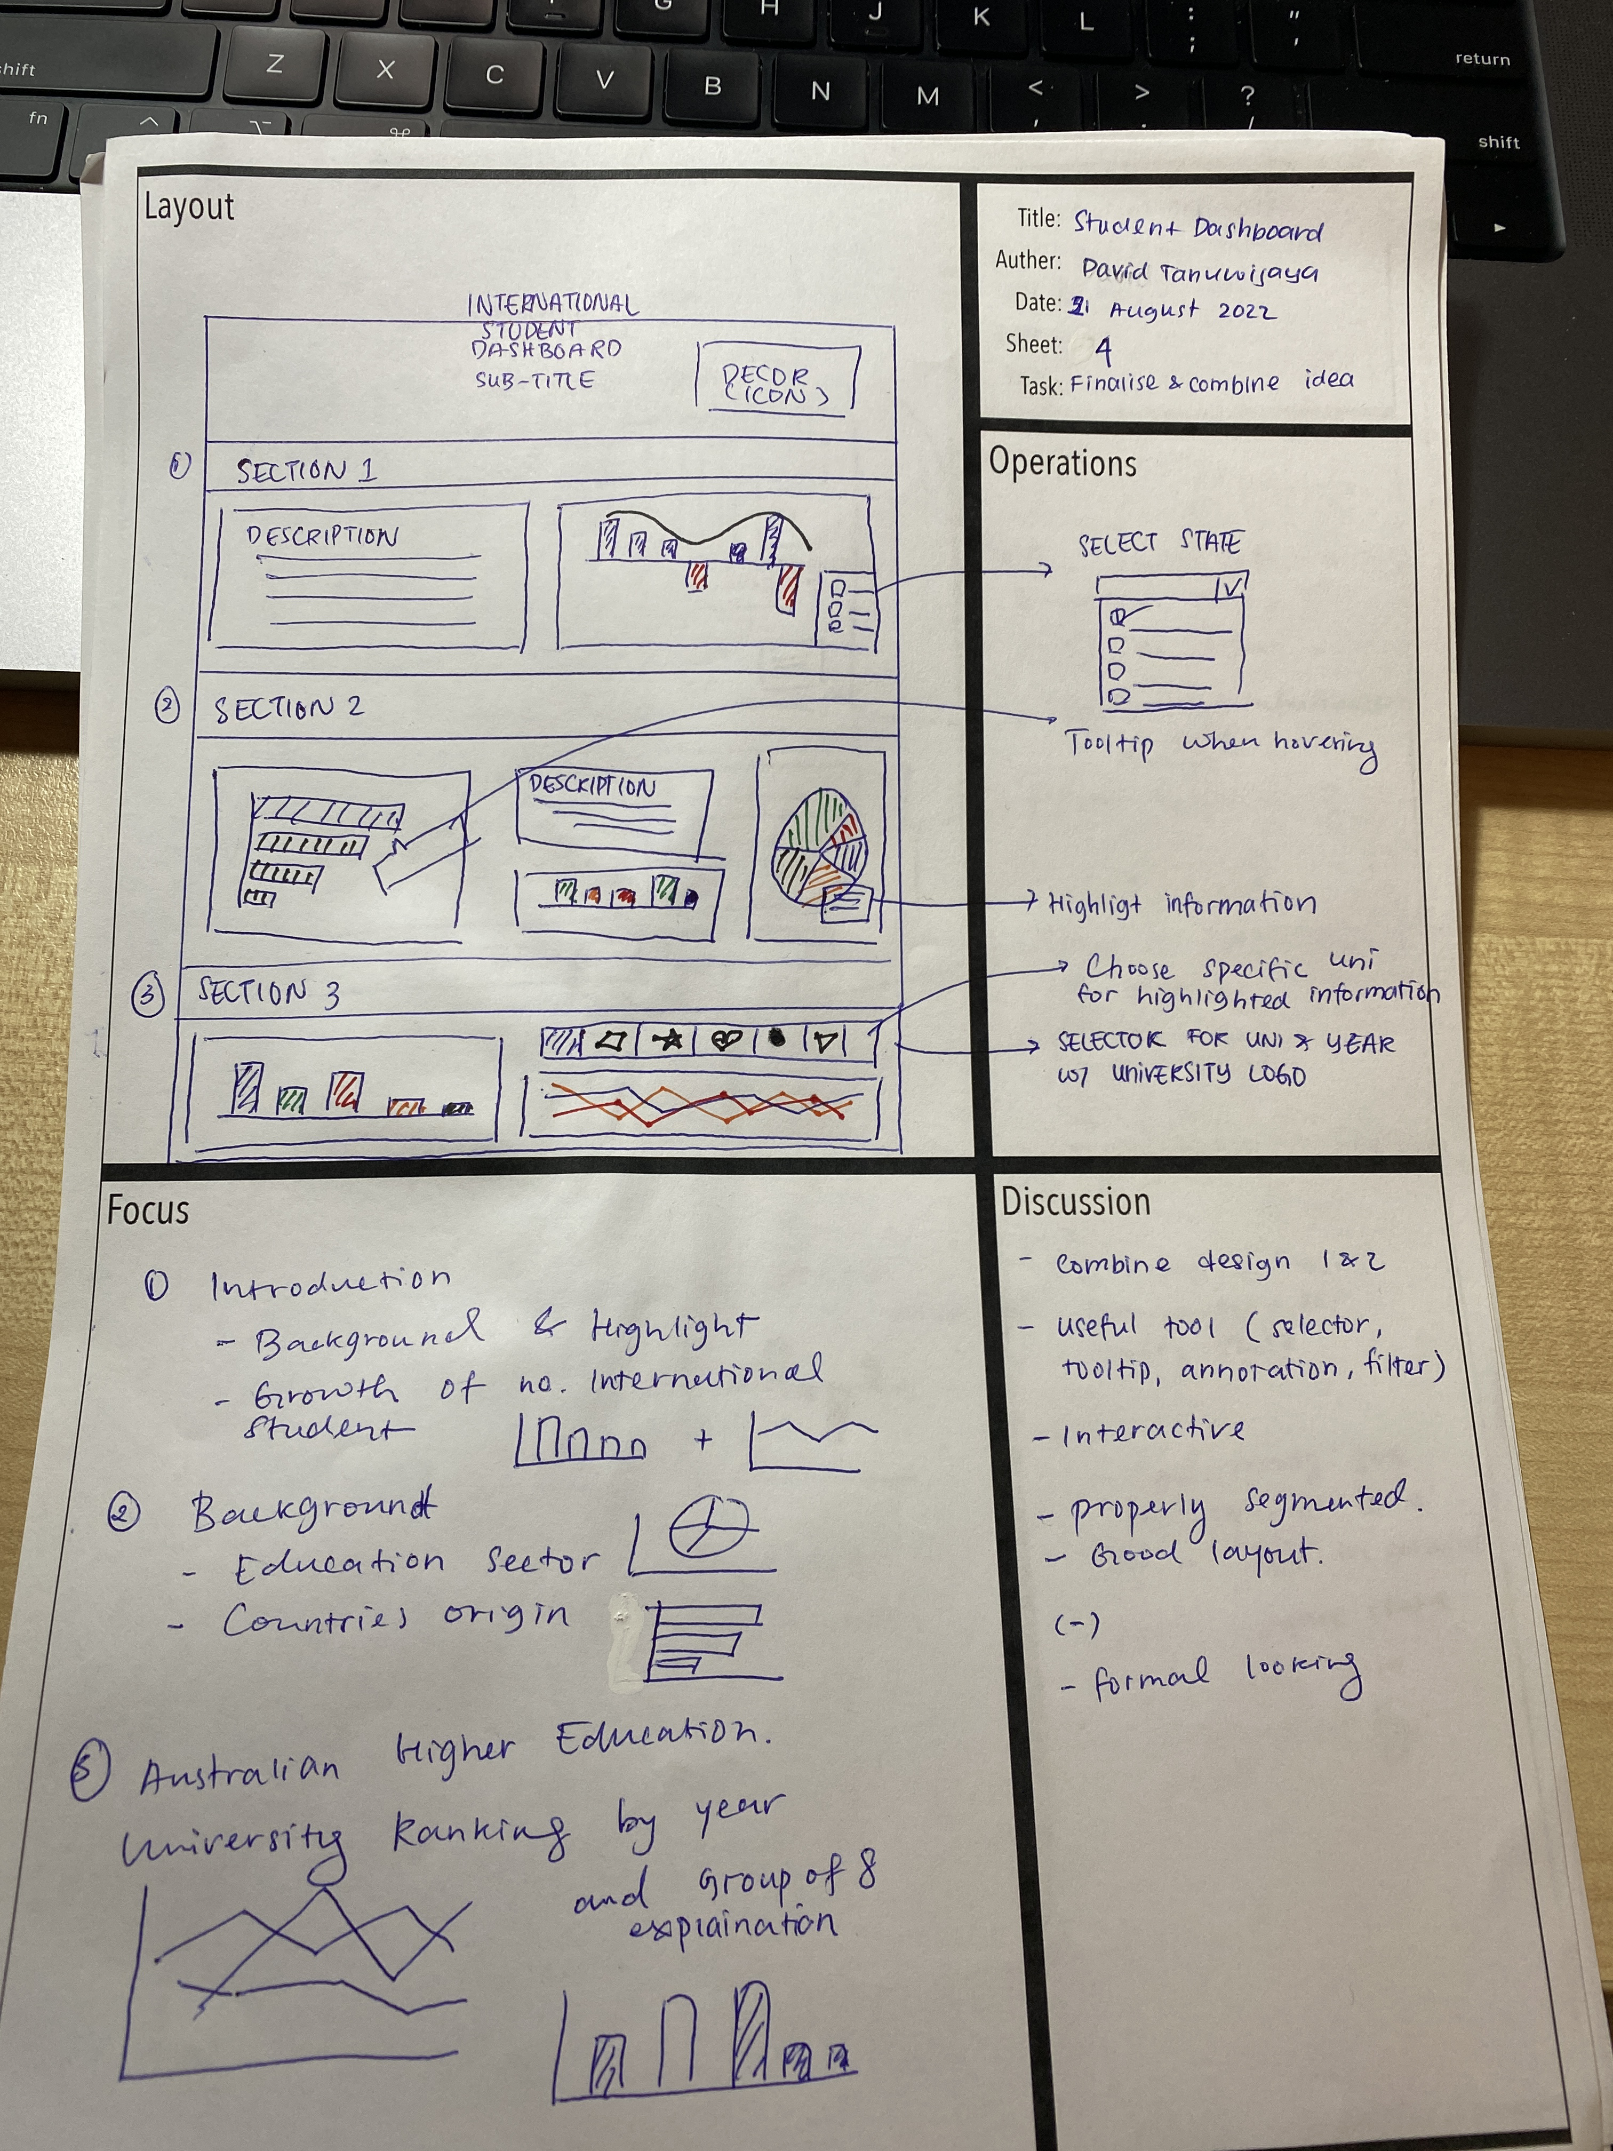

Sheet 5

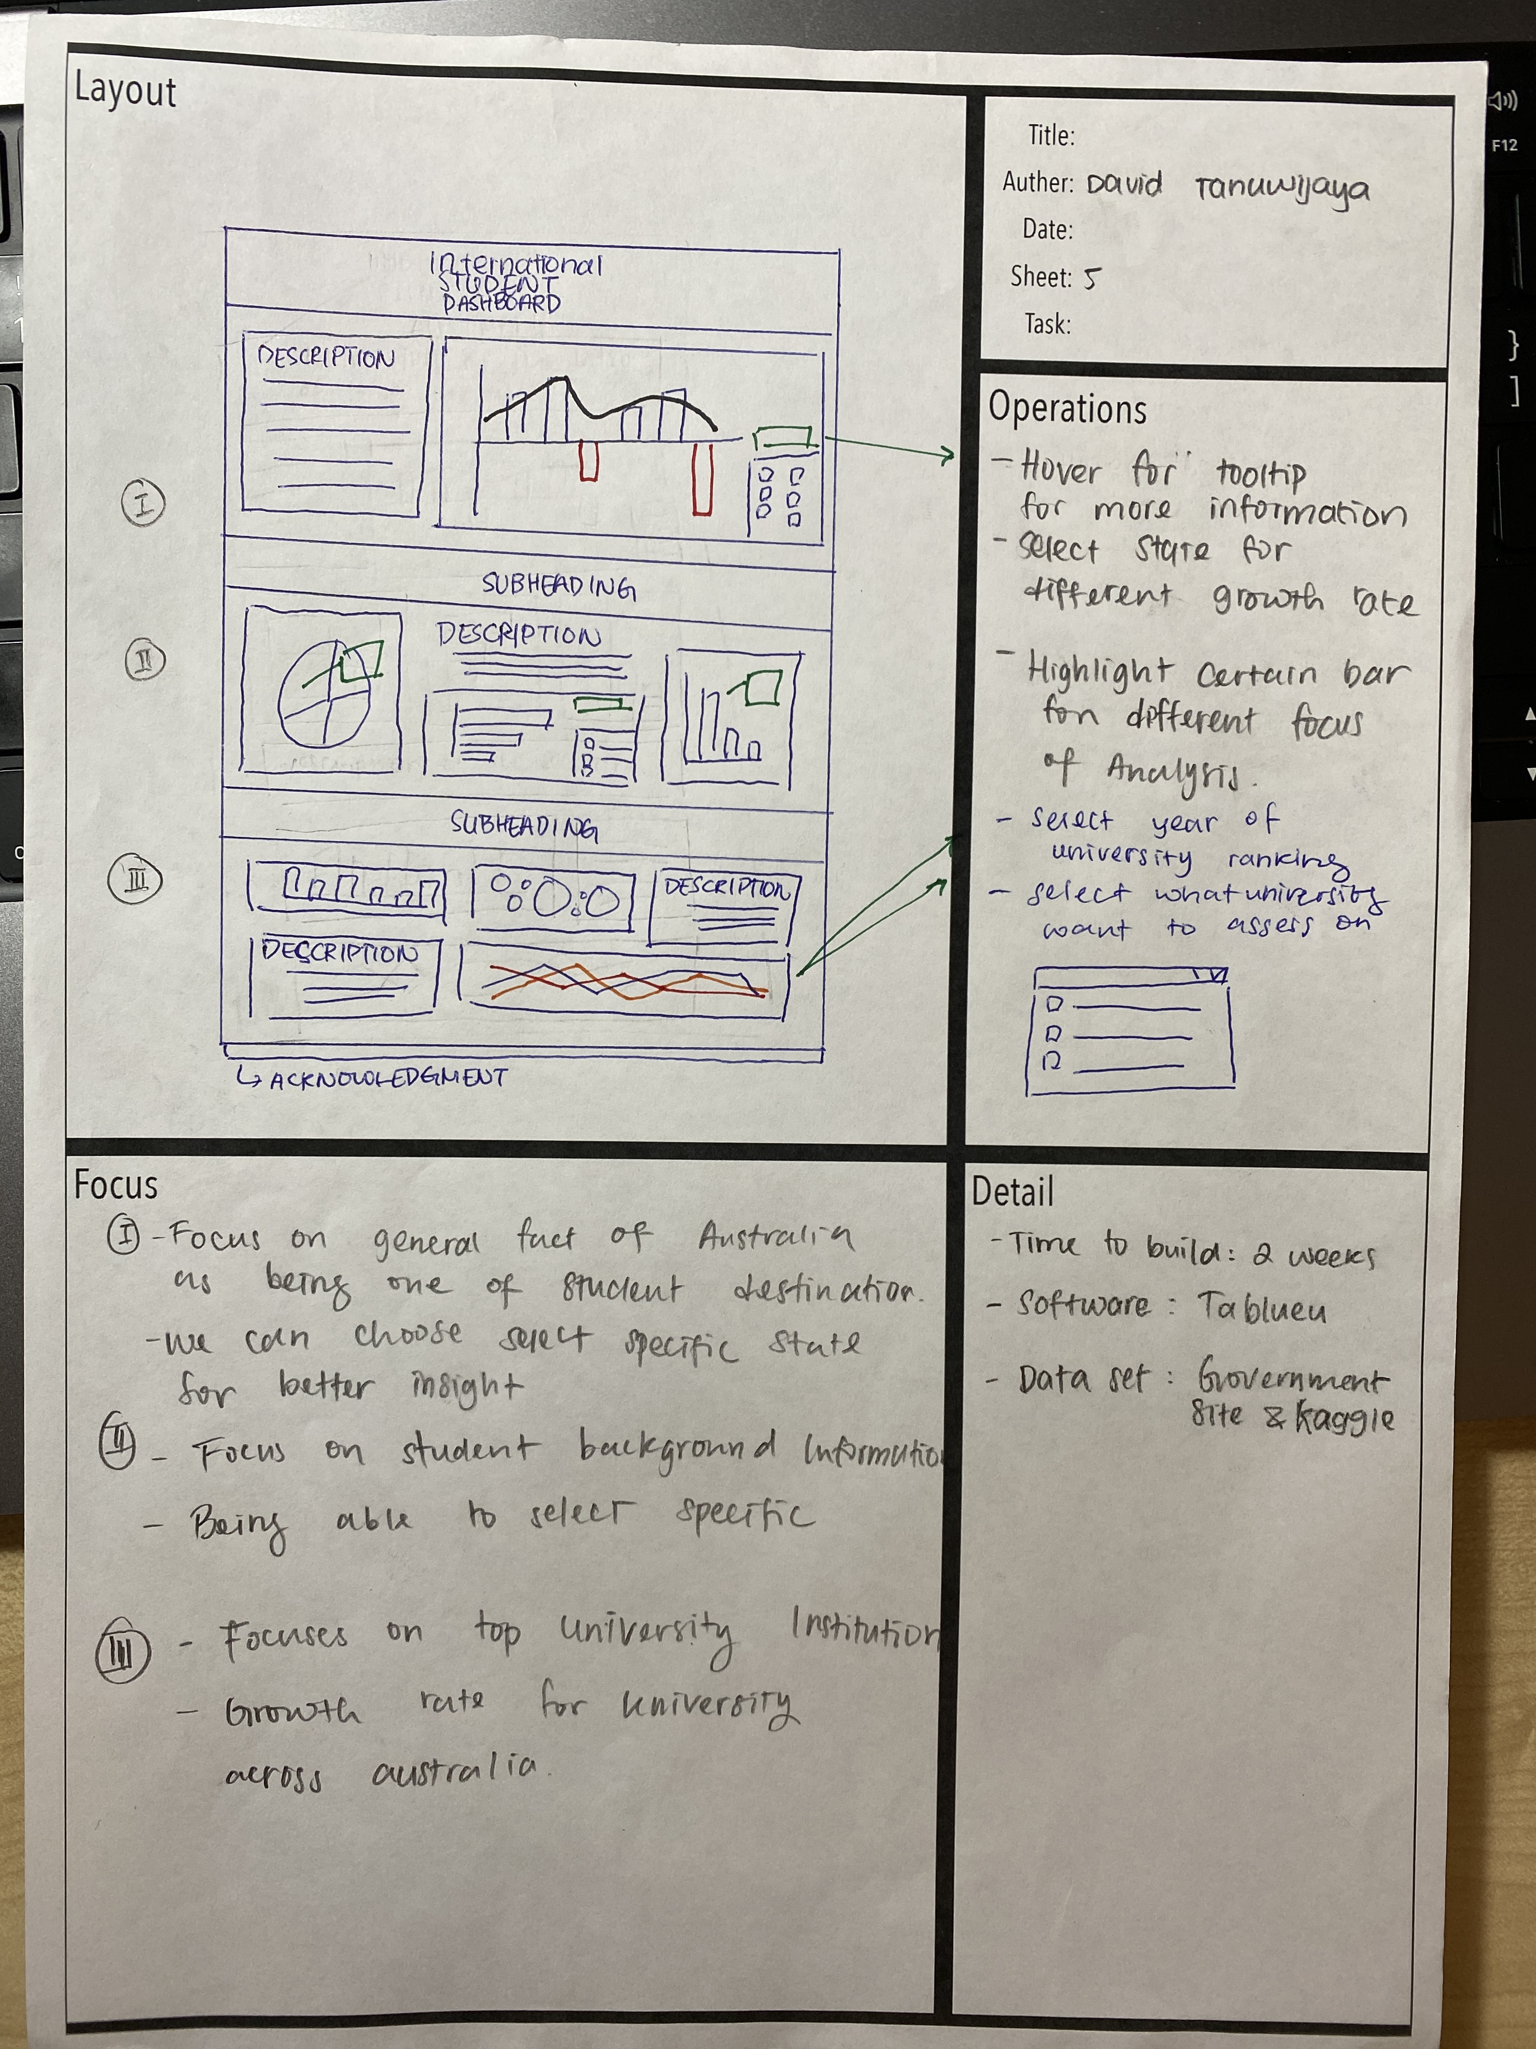

**References**